# Configure Docker Containers for Telegraf, InfluxDB and Grafana

* Username: nessdemo
* Pwd: nessdemo

# Grafana – Datasource as InfluxDB

# Grafana – Datasource as AWS CloudWatch

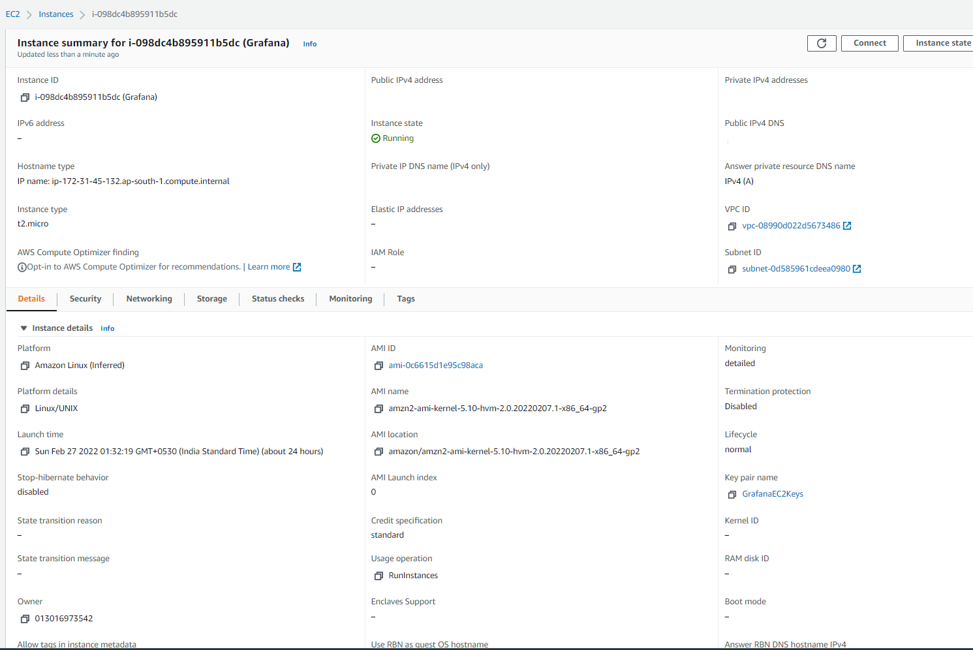

# Step Docker Composer

